
Summative Assessment Memo

Module 09 – Deep Learning
Occupational Certificate: Artificial Intelligence Software Developer

Module # | 251201-002-00-KM-09
NQF Level | 5
Notional hours | 160
Credit(s) | 16
Curriculum Code | 251201002
Qualification Title | Occupational Certificate: Artificial Intelligence Software Developer

CONTACT INFORMATION:
Name
Contact Address
Telephone (H)
Telephone (W)
Cellular

PURPOSE OF THE KNOWLEDGE MODULE
The main focus of the learning in this knowledge module is to build an understanding of the relationship between Artificial Intelligence, Machine Learning and Deep Learning, as well as the application of Deep Learning to create a set of instructions to perform a programming task using a Deep Learning tool

PROVIDER ACCREDITATION REQUIREMENTS FOR THE MODULE:

Physical Requirements:
- The provider must have lesson plans and structured learning material or provide learners with access to structured learning material that addresses all the topics in all the knowledge modules as well as the applied knowledge in the practical skills.
- QCTO/ MICT SETA requirements
Human Resource Requirements:
- Lecturer/learner ratio of 1:20 (Maximum)
- Qualification of lecturer (SME):
- NQF 6 in industry recognised qualifications with 1 year’s experience in the IT industry
- AI vendor certification (where applicable)
- Assessors and moderators: accredited by the MICT SETA
Legal Requirements:
- Legal (product) licences to use the software for learning and training (where applicable)
- OHS compliance certificate
- Ethical clearance (where necessary)
Exemptions
- No exemptions, but the module can be achieved in full through a normal RPL process

TOPIC ELEMENTS TO BE COVERED INCLUDE:
- KM-09-KT01 : Deep Learning (DL)
- KM-09-KT02 : Advance Python for Deep Learning
- KM-09-KT03 : TensorFlow and Keras for Deep Learning

SECTION 1: KM-09-KT01:Deep Learning (DL)

What is neural network and its layers?

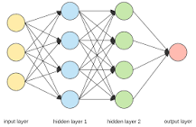

The Neural Network is constructed from 3 type of layers: Input layer — initial data for the neural network. Hidden layers — intermediate layer between input and output layer and place where all the computation is done. Output layer — produce the result for given inputs.

What is neural network in DL?
A neural network is made up of vertically stacked components called Layers. Each dotted line in the image represents a layer. There are three types of layers in a NN- Input Layer– First is the input layer. This layer will accept the data and pass it to the rest of the network.

What are activation functions in TensorFlow?

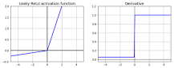

7 popular activation functions you should know in Deep Learning and how to use them with Keras and TensorFlow 2
- Sigmoid (Logistic)
- Hyperbolic Tangent (Tanh)
- Rectified Linear Unit (ReLU)
- Leaky ReLU.
- Parametric Leaky ReLU (PReLU)
- Exponential Linear Units (ELU)
- Scaled Exponential Linear Unit (SELU)

What is the most common activation function?

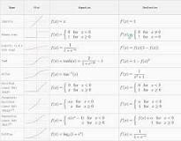

The ReLU is the most used activation function in the world right now. Since, it is used in almost all the convolutional neural networks or deep learning.

What is CNN deep learning?

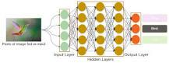

In deep learning, a convolutional neural network (CNN/ConvNet) is a class of deep neural networks, most commonly applied to analyze visual imagery. Now when we think of a neural network we think about matrix multiplications but that is not the case with ConvNet. It uses a special technique called Convolution.

What is an activation function in deep learning?

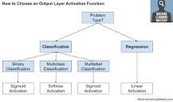

An activation function in a neural network defines how the weighted sum of the input is transformed into an output from a node or nodes in a layer of the network.

What is activation function and its types?
An activation function is a very important feature of an artificial neural network , they basically decide whether the neuron should be activated or not. In artificial neural networks, the activation function defines the output of that node given an input or set of inputs.

What is tuning in neural network?

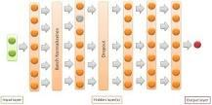

The hyperparameters to tune are the number of neurons, activation function, optimizer, learning rate, batch size, and epochs. The second step is to tune the number of layers. This is what other conventional algorithms do not have. Different layers can affect the accuracy.

What is tuning of model?
Tuning is the process of maximizing a model's performance without overfitting or creating too high of a variance. In machine learning, this is accomplished by selecting appropriate “hyperparameters.” Hyperparameters can be thought of as the “dials” or “knobs” of a machine learning model.

SECTION 2: KM-09-KT02: Advance Python for Deep Learning

What is a decorator function in Python?

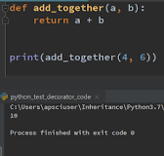

A decorator in Python is a function that takes another function as its argument, and returns yet another function . Decorators can be extremely useful as they allow the extension of an existing function, without any modification to the original function source code

What are decorators in programming?

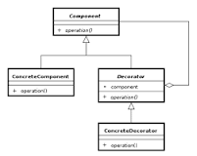

In object-oriented programming, the decorator pattern is a design pattern that allows behavior to be added to an individual object, dynamically, without affecting the behavior of other objects from the same class.

What is the with statement in Python?
The with statement in Python is used for resource management and exception handling. You'd most likely find it when working with file streams. For example, the statement ensures that the file stream process doesn't block other processes if an exception is raised, but terminates properly.

In Python, exceptions can be handled using a try statement. The critical operation which can raise an exception is placed inside the try clause. The code that handles the exceptions is written in the except clause.

SECTION 3: KM-09-KT03: TensorFlow and Keras for Deep Learning

What does tensor mean in TensorFlow?
A tensor is a generalization of vectors and matrices to potentially higher dimensions. Internally, TensorFlow represents tensors as n-dimensional arrays of base datatypes. When writing a TensorFlow program, the main object you manipulate and pass around is the tf$Tensor .

What Does Control Structure Mean?
A control structure is a codebase portion that supports decisions based on analysis of variables. These functional components are eminently useful in computer science and computer programming.

What is TensorFlow Keras API?
Keras is the high-level API of TensorFlow 2: an approachable, highly-productive interface for solving machine learning problems, with a focus on modern deep learning. It provides essential abstractions and building blocks for developing and shipping machine learning solutions with high iteration velocity.

What is a configuration layer?
The configuration layer is a customized set of metadata that can be used to configure data sources and variables more easily for a report. This metadata is determined by the document designer and stored in the template to be used during document generation.

What Does Data Loading Mean?
Data loading is the process of copying and loading data or data sets from a source file, folder or application to a database or similar application. It is usually implemented by copying digital data from a source and pasting or loading the data to a data storage or processing utility.

A complex model of social enterprise combines two or more operational models. Complex models are flexible; virtually any number or type of operational models can be combined into one social enterprise. Models are combined to achieve desired impact and revenue objectives.

